Class: COMP 3090 - Database I

Name: DangNhi Ngoc Ngo

Email: DangNhi_Ngo@student.uml.edu

Student ID: 01553277

**HOMEWORK #4**

**Exercise 6.1.3:**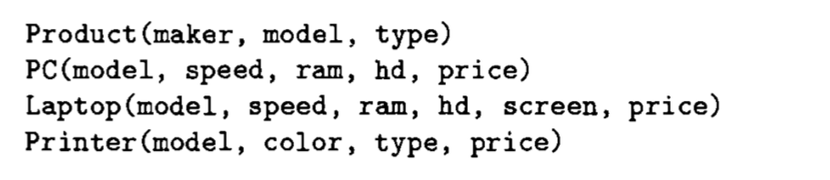

**a) Find the model number, speed, and hard-disk size for all PC’s whose price is under $1000**

SELECT model, speed, hd

FROM PC

WHERE price < 1000;

Result of query:

|  |  |  |
| --- | --- | --- |
| model | speed | hd |
| 1002 | 2.10 | 250 |
| 1003 | 1.42 | 580 |
| 1004 | 2.80 | 250 |
| 1005 | 3.20 | 250 |
| 1007 | 2.20 | 200 |
| 1008 | 2.20 | 250 |
| 1009 | 2.00 | 250 |
| 1010 | 2.80 | 300 |
| 1011 | 1.86 | 160 |
| 1012 | 2.80 | 160 |
| 1013 | 3.06 | 80 |

**c) Find the manufacturers of printers**

SELECT DISTINCT maker

FROM Product

WHERE type = ‘printer’;

Result of query:

|  |
| --- |
| maker |
| D |
| E |
| H |

**d) Find the model number, memory size, and screen size for laptops costing more than $1500**

SELECT model, ram, screen

FROM Laptop

WHERE price > 1500;

Result of query:

|  |  |  |
| --- | --- | --- |
| model | ram | screen |
| 2001 | 2048 | 20.1 |
| 2005 | 1024 | 17.0 |
| 2006 | 2048 | 15.4 |
| 2010 | 2048 | 15.4 |

**Exercise 6.2.2:**



**b)** **Find the model number and price for all products (of any type) made by manufacture B**

SELECT P.model, PC.price

FROM Product P, PC

WHERE P.maker = ‘B’ AND P.model = PC.model

UNION

SELECT P.model, L.price

FROM Product P, Laptop L

WHERE P.maker = ‘B’ AND P.model = L.model

UNION

SELECT P.model, PR.price

FROM Product P, Printer PR

WHERE P.maker = ‘B’ AND P.model = PR.model;

Result of query:

|  |  |
| --- | --- |
| model | price |
| 1004 | 649 |
| 1005 | 630 |
| 1006 | 1049 |
| 2007 | 1429 |

**c) Find those manufacturers that sell Laptops, but not PC’s**

SELECT DISTINCT maker

FROM Product P

WHERE P.type = ‘Laptop’

EXCEPT

SELECT DISTINCT maker

FROM Product P

WHERE P.type = ‘PC’;

Result of query:

|  |
| --- |
| maker |
| F |
| G |

**e) Find those pairs of PC models that have both the same speed and RAM. A pair should be listed only once; e.g., list (i,j) but not (j,i)**

SELECT PC1.model, PC2.model

FROM PC PC1, PC PC2

WHERE PC1.model < PC2.model and PC1.speed = PC2.speed AND PC1.ram = PC2.ram;

Result of query:

|  |  |
| --- | --- |
| PC1.model | PC2.model |
| 1004 | 1012 |

**Exercise 6.3.1:**



**a)** **Find the makers of PC’s with a speed of at least 3.0**

SELECT DISTINCT maker

FROM Product

WHERE model IN (SELECT model FROM PC WHERE speed >= 3.0);

Result of query:

|  |
| --- |
| maker |
| B |
| E |

**b) Find the printers with the highest price**

SELECT model

FROM Printer

WHERE price >= ALL (SELECT price FROM Printer);

Result of query:

|  |
| --- |
| model |
| 3003 |

**c) Find the laptops whose speed is slower than that of any PC**

SELECT model

FROM Laptop

WHERE speed <= ~~ALL~~ ANY(SELECT speed FROM PC);

Result of query:

|  |
| --- |
| model |
| 2001 |
| 2002 |
| 2003 |
| 2004 |
| 2005 |
| 2006 |
| 2007 |
| 2008 |
| 2009 |
| 2010 |

**e) Find the maker of the color printer with the lowest price**

SELECT DISTINCT maker

FROM Product P, Printer PR

WHERE color = true

AND P.model = PR.model

AND price <= ALL (SELECT price FROM Printer WHERE color = true);

Result of query:

|  |
| --- |
| maker |
| E |